**CS 3050 Homework # 4. Name :**

**Submitted to Blackboard, due at 11:59pm on March 16, 2017.**

1. Write pseudocode for RIGHT-ROTATE by modifying the algorithm in Figure 13.3 of the textbook.

2. Draw the red-black trees that result after successively inserting the keys P, S, E, U, D, O, C into an initially empty red-black tree. The order of letters are alphabetical. You may use filled circles to indicate black and unfilled circles to indicate red.

3. Design a “worst-case” red-black tree with 10 nodes, i.e., a red-black tree with the longest possible path from the root to a leaf.

4. For the following order-statistics tree T, (1) show how OS-SELECT (T, 9) operates; (2) show how OS-RANK(T, 35) operates.

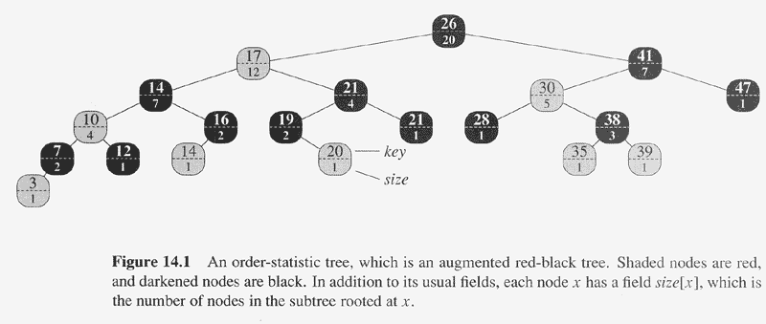

5. Given an interval tree T and an interval i , describe how to list all intervals in T that overlap i efficiently using pseudo code. [Hint: There are multiple ways to solve it. One way is to check both right and left subtrees from the root iteratively.]